***Team :***

We have decided on a 3-man team composed of the following students : Stan Andrei (3E3), Vasilica Georgiana (3E1), Dumitru Mihai (3E2).

***Game type :***

We’d like to create a top-down 2d shoot-em-up type of game combined with rpg elements (possible elements such as : map exploration, crafting, upgrades, equipment, creature / npc - player dialogue, environment interactions, etc).

***Game concept :***

The concept of the game is simple, move around and kill your enemies with whatever you have (aka a run n’ gun). The game will be dynamiclly modifying the players environment based on progression, having interchangable elements (such as creatures, objects, etc), the players progression is based on continuous rounds of shoot-em-up levels, these interchangable maps being a possible resting point for the player if they so desire. The sprites / design of these maps, creatures, objects and so on will be based on pixel art, simple and yet efficent clip-art.

***Similar games :***

* Soul knight : <http://www.chillyroom.com/en> (<https://play.google.com/store/apps/details?id=com.ChillyRoom.DungeonShooter>)
* Enter the Gungeon : <https://store.steampowered.com/app/311690/Enter_the_Gungeon/>
* Neon abyss : <https://store.steampowered.com/app/788100/Neon_Abyss/>

***The map / levels :***

* A resting room where the player can stay before he begins his adventures
* Once the player leaves the room (via the big door in the top - middle) they will go through multiple zones (each zone having multiple levels and different world aspects and enemies)
* Each level will be generated using multiple pre-defined rooms, however these rooms will be set at random, to generate a almost unique feel at every play-through
* The player has a minimap with a sketch of how the rooms are placed, however they won’t know what each room contains unless they visit it

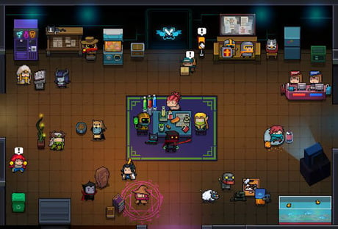

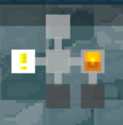

***The gameplay :***

* Each weapon (gun) that the player uses has a mana cost, the player having a base 200 mana bar, you can recover mana by defeating enemies, aside of gaining mana from enemies, you can also gain coins, which will allow you to purchase all kinds of things (buffs, hiring npcs, gaining new weapons, etc)
* Each level contians multiple rooms that can have chests, shops, hireable npcs and so on, the player can choose to either go through every room, on every level to raise their chances to beat later levels, or they can speed-run through the level – searching only for the portal that leads to the next level
* After every couple of rooms, you get to choose one of three random buffs to help you on your adventure (such as : a larger mana bar, a chance to regen health after killing an enemy, a higher chance to crit an enemy, greater luck etc)
* Each zone ends with a boss battle, in which if the player succeeds, the boss will drop a chest and a portal, so the player can go to the next zone
* The player has to go through these zones and levels to reach the end of the „playthrough”, however since the map generation is randomised and even more-so the loot (weapons, enchantments, buffs, etc), there really is no „end” to the game.
* You also have a set hp and shield bar, while you cannot heal (unless you use a potion, or you have the vampiric effect) you do regenerate your shield, which regenerates after a few seconds of not taking damage.

